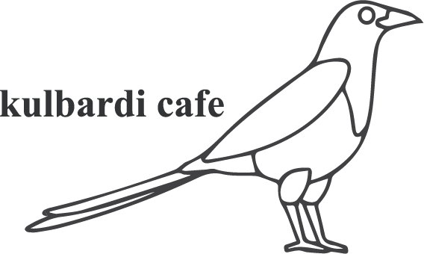

Made to order options

Fresh sandwich – white or multigrain
Filing options: ham, chicken, egg, falafel, lettuce, carrot, cheese, onion, tomato
Add on: avocado $0.50, beetroot $0.20

Fresh roll
Filing options: ham, chicken, egg, falafel, lettuce, carrot, cheese, onion, tomato
Add on: avocado $0.50, beetroot $0.20

Fresh wrap
Filing options: ham, chicken, egg, falafel, lettuce, carrot, cheese, onion, tomato
Add on: avocado $0.50, beetroot, $0.20

Toasties
Options: ham & cheese, chicken & cheese, tomato, onion & cheese
Add on: avocado $0.50

